**WAD**

**ASSIGNMENT 9**

Q. Create a web application using Express.js which will use the app object includes get() and post() method which defines routes for HTTP GET and POST requests.

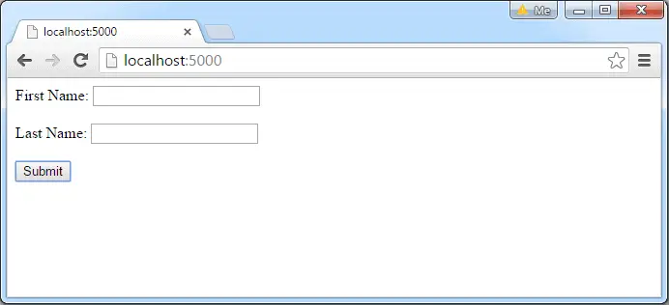

HTML Form to submit POST request

OUTPUT: Ramesh Chandra Submitted Successfully!